NOISE POLLUTION MONITORING

PHASE – 05 submission document

**ABSTRACT:**

Noise pollution monitoring is the process of measuring and assessing levels of noise in the environment to understand its impact on human health and the ecosystem. Monitoring noise pollution is essential for implementing effective noise control measures and ensuring that noise levels comply with local regulations. Here are some key aspects of noise pollution monitoring: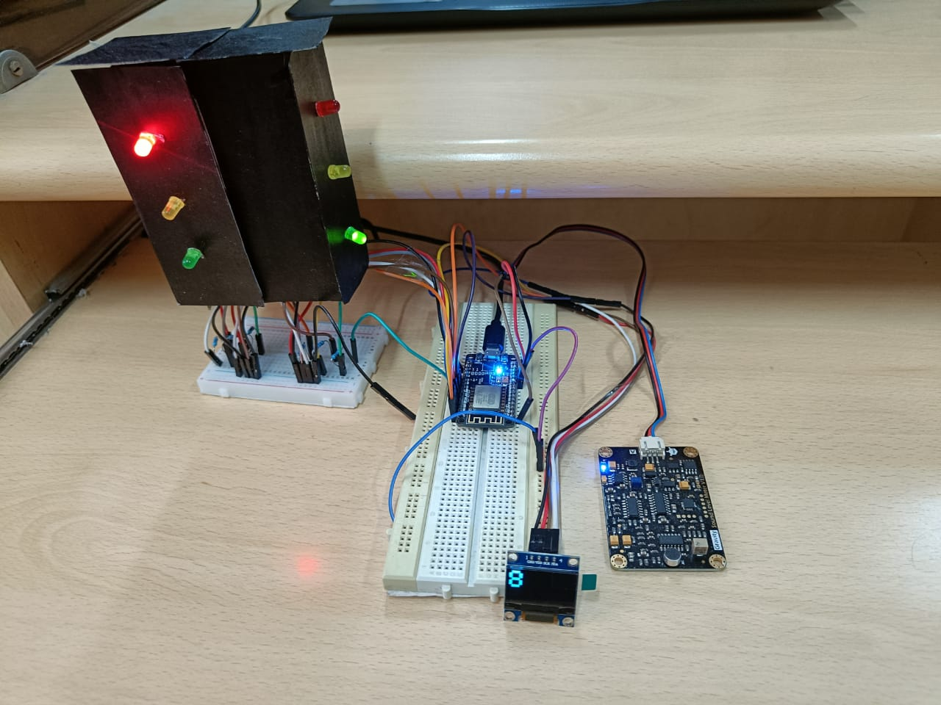

MODULES:

**1.Noise Measurement**: Monitoring typically involves measuring sound levels using specialized equipment called sound level meters or noise dosimeters. These devices record sound pressure levels in decibels (dB) and capture data over a specific period.

**2.Monitoring Locations**: Noise monitoring should be conducted in various locations to capture a comprehensive picture of noise pollution. Common sites include urban areas, industrial zones, residential neighborhoods, and places near transportation hubs.

**3.Duration of Monitoring**: Monitoring can be continuous or conducted for specific durations, such as 24 hours or a few days, to assess daily and nighttime noise levels.

**4.Data Analysis**: Collected data is analyzed to determine average noise levels, peak noise events, and patterns of noise pollution. Statistical methods may be employed to assess the data.

**5.Noise Mapping**: To visualize noise pollution, noise maps can be created. Geographic Information Systems (GIS) technology is often used to generate noise maps, which provide a spatial representation of noise levels.

**6.Compliance with Regulations**: Noise monitoring helps ensure that noise levels comply with local regulations, such as noise ordinances or permissible levels in industrial areas. If violations are identified, authorities can take corrective actions.

**7.Community Feedback**: Public input can be valuable in noise pollution monitoring. Residents can report noise complaints, and their feedback can be integrated into monitoring efforts.

**8.Environmental Impact Assessment**: In addition to its impact on human health, noise pollution can affect wildlife and ecosystems. Monitoring may involve assessing how noise disrupts natural habitats and behaviors.

**9.Noise Source Identification**: Noise monitoring can also help identify specific sources of noise pollution. This information is crucial for targeted mitigation efforts.

**10.Long-Term Trends**: Continuous noise monitoring over years can reveal long-term trends and assess the effectiveness of noise control measures.

**11.Public Awareness**: Noise pollution monitoring can raise public awareness about the issue and encourage responsible noise management practices.

**12.Noise Control Measures**: Based on monitoring results, appropriate noise control measures can be implemented, which may include sound barriers, noise insulation, quieter equipment, and changes in land use planning.

**13.Research and Policy Development**: Noise monitoring data can contribute to research on noise pollution's health effects and inform the development of noise-related policies and regulations.

Noise pollution monitoring is a crucial tool for maintaining a healthy and livable environment. It helps authorities make informed decisions to mitigate noise pollution, protect public health, and improve the quality of life in affected areas. Additionally, advancements in technology, including the use of sensors and data analytics, are making noise monitoring more efficient and accurate.

Top of Form

INNOVATION:

**1.Data Collection:**

* Gather noise level data from various sources, such as noise monitoring sensors, mobile apps, or existing databases. This data can include decibel levels, timestamps, and geographic coordinates.

**2.Data Integration:**

* Integrate data from multiple sources into a centralized database or data management system. Ensure data is in a consistent format and includes relevant metadata.

**3.Data Preprocessing:**

* Clean the data by handling missing values, outliers, and inconsistencies.
* Convert timestamps into a standardized format for easy analysis.
* Geocode geographic coordinates to convert them into meaningful locations.

**4.Noise Mapping:**

* Create noise maps using geographic information system (GIS) tools. These maps will visualize noise levels in different areas.
* Apply interpolation techniques to estimate noise levels in areas with limited data points.

**5.Pattern Identification:**

* Use statistical analysis and data visualization techniques to identify noise pollution patterns. Look for trends, seasonality, and spatial correlations.
* Cluster analysis can help identify high-noise areas and distinguish different noise sources.

**6.Machine Learning Models:**

* Train machine learning models to predict noise levels based on various features such as time of day, weather conditions, traffic data, and land use.
* Use regression models or time series analysis for predictive modeling.

**7.Source Identification**:

* Employ acoustic sensors or sound classification models to identify specific noise sources (e.g., traffic, industrial processes, construction).
* Use clustering and feature importance analysis to pinpoint major contributors to noise pollution.

**8.Alerting and Reporting:**

* Implement real-time or periodic monitoring to alert relevant authorities or stakeholders when noise levels exceed acceptable thresholds.
* Generate reports and dashboards to communicate noise pollution insights to decision-makers and the public.

**9.Mitigation Strategies:**

* Develop noise mitigation strategies based on the identified sources and patterns. This may include implementing noise barriers, adjusting traffic flow, or modifying land use regulations.

**10.Continuous Monitoring and Feedback:**

* Maintain ongoing data collection and analysis to assess the effectiveness of mitigation efforts.
* Adjust strategies as needed based on new data and feedback.

**11.Public Engagement:**

* Involve the community in noise pollution awareness campaigns and data collection efforts.
* Encourage citizens to report noise complaints through mobile apps or web platforms.

**12.Legal and Policy Considerations:**

* Ensure compliance with noise regulations and local ordinances.
* Advocate for noise pollution reduction policies based on data-driven evidence.

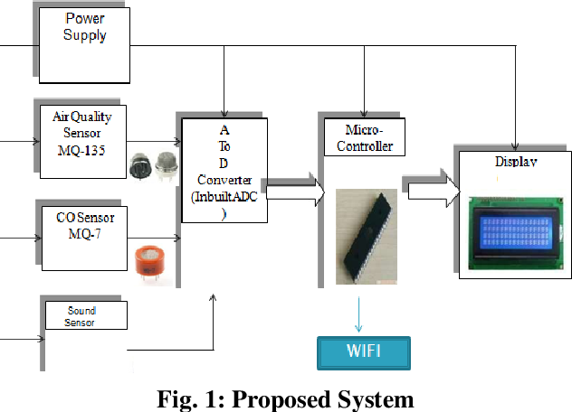

BLOCK DIAGRAM OF NOISE POLLUTION MONITORING

DEVELOPMENT PART - 1

**1.Identify Sensor Locations:**

* + Identify public areas where noise levels need monitoring, such as parks, busy streets, or event venues.
  + Consider local regulations and guidelines for noise monitoring.

**2.Define Objectives:**

* + Clearly define the objectives of noise monitoring. This could be to assess the impact on public health, enforce noise regulations, or analyze trends over time.

**Technology Selection:**

1. **Choose Noise Sensors:**
   * Select appropriate noise sensors that meet your requirements. Consider factors like accuracy, frequency range, and connectivity options (Wi-Fi, cellular, LPWAN).
2. **Communication Infrastructure:**
   * Decide on the communication infrastructure for the sensors. Options include Wi-Fi, cellular networks, or Low-Power Wide-Area Network (LPWAN) technologies like LoRa or NB-IoT.

**Implementation:**

1. **Power Supply:**
   * Determine the power supply for the sensors. Options include battery power, solar panels, or a combination of both. Ensure that the chosen power source is reliable for continuous operation.
2. **Sensor Deployment:**
   * Install sensors in identified locations. Consider weatherproofing and security measures to protect the sensors from environmental conditions and vandalism.
3. **Connectivity Setup:**
   * Configure the connectivity for the sensors. Ensure that they can transmit data reliably to a central data storage or processing system.
4. **Data Storage and Processing:**

* This could be on a cloud platform or a local server, depending on the scale of your deployment.

**Data Analysis and Visualization:**

1. **Data Analysis Tools:**
   * Implement tools and algorithms for analyzing noise data. This could involve identifying noise trends, peak hours, and compliance with noise regulations.
2. **Visualization Platform:**
   * Develop a user-friendly platform for visualizing the data. Consider creating dashboards that provide real-time information and historical trends.

**Maintenance and Monitoring:**

1. **Maintenance Plan:**
   * Establish a regular maintenance plan to ensure the sensors are functioning correctly. This includes checking the power supply, updating firmware, and replacing faulty sensors.
2. **Security Measures:**
   * Implement security measures to protect the sensors and data from unauthorized access. This is crucial to maintain the integrity and privacy of the collected information.

**Compliance and Communication:**

1. **Regulatory Compliance:**
   * Ensure that your noise monitoring system complies with local regulations and privacy laws.
2. **Public Communication:**
   * Communicate the purpose of the noise monitoring system to the public. Transparency helps build trust and may encourage compliance with noise regulations.

Python code:

import time

import random

import paho.mqtt.client as mqtt

import requests

# Replace these values with your actual credentials and endpoints

SENSOR_ID = "YOUR_SENSOR_ID"

API_KEY = "YOUR_API_KEY"

API_ENDPOINT = "https://your-api-endpoint.com/data"

# MQTT Configuration

MQTT_BROKER = "mqtt.eclipse.org" # Replace with your MQTT broker address

MQTT_PORT = 1883

MQTT_TOPIC = "noise_sensor_data"

# Simulated Noise Sensor Data

def generate_noise_data():

return round(random.uniform(50, 80), 2) # Replace with your actual noise data source

# MQTT Callbacks

def on_connect(client, userdata, flags, rc):

print("Connected with result code " + str(rc))

client.subscribe(MQTT_TOPIC)

def on_message(client, userdata, msg):

noise_level = float(msg.payload.decode())

print(f"Received noise level: {noise_level} dB")

# Send data to the API endpoint

send_data_to_api(noise_level)

def send_data_to_api(noise_level):

headers = {

"Content-Type": "application/json",

"Authorization": f"Bearer {API_KEY}",

}

data = {

"sensor_id": SENSOR_ID,

"noise_level": noise_level,

"timestamp": int(time.time()),

}

try:

response = requests.post(API_ENDPOINT, json=data, headers=headers)

if response.status_code == 200:

print("Data sent successfully")

else:

print(f"Failed to send data. Status code: {response.status_code}")

except Exception as e:

print(f"Error sending data: {str(e)}")

# MQTT Client Setup

mqtt_client = mqtt.Client()

mqtt_client.on_connect = on_connect

mqtt_client.on_message = on_message

# Connect to MQTT broker

mqtt_client.connect(MQTT_BROKER, MQTT_PORT, 60)

# Start the MQTT loop

mqtt_client.loop_start()

try:

while True:

# Simulate noise data and publish to MQTT

noise_data = generate_noise_data()

mqtt_client.publish(MQTT_TOPIC, str(noise_data))

print(f"Published noise level: {noise_data} dB")

time.sleep(5) # Adjust the interval based on your requirements

except KeyboardInterrupt:

print("Script terminated by user.")

mqtt_client.disconnect()

Explanation:

* The script uses the **paho.mqtt.client** library for MQTT communication. Install it using **pip install paho-mqtt**.
* Replace the placeholders (**YOUR_SENSOR_ID**, **YOUR_API_KEY**, **API_ENDPOINT**, etc.) with your actual values.
* The **generate_noise_data** function simulates the noise level data. Replace it with the actual function or sensor data source.
* The script subscribes to an MQTT topic (**noise_sensor_data**) to receive real-time noise data.
* Upon receiving the data, the script sends it to the specified API endpoint using an HTTP POST request.

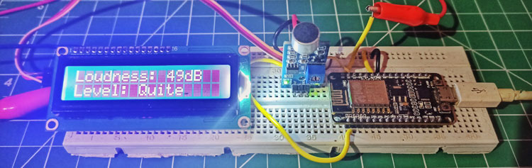

RASPBERRY DIAGRAM OF NOISE POLLUTION MONITORING

DEVELOPMENT PART - 02

1. **Planning:**
   * Define the project scope, objectives, and target audience.
   * Create a detailed project plan with milestones and timelines.
   * Establish a budget and allocate resources.
2. **Research and Data Collection:**
   * Gather noise pollution data sources such as sensors, government reports, and user-generated content.
   * Identify the key metrics for noise pollution assessment.
3. **Design:**
   * Develop wireframes and mockups for the mobile app's user interface.
   * Design the platform's website or portal.
   * Ensure a user-friendly and intuitive design.
4. **Development:**
   * Start by building the backend infrastructure for the platform, including a database to store noise data.
   * Develop the mobile app for both iOS and Android platforms.
   * Implement features such as noise level monitoring, mapping, and data visualization.
5. **Data Integration:**
   * Set up automated data collection and integration from various sources.
   * Implement algorithms to process and analyze noise data.
6. **User Registration and Profiles:**
   * Create user registration and profile management systems.
   * Allow users to customize notification preferences.
7. **Notifications and Alerts:**
   * Implement a system for real-time noise level notifications.
   * Send alerts to users when noise levels exceed predefined thresholds.
8. **Data Visualization:**
   * Develop interactive maps and graphs to display noise data.
   * Provide historical noise pollution trends and insights.
9. **Community Engagement:**
   * Enable users to report noise disturbances and contribute data.
   * Add social features like forums or discussion boards.
10. **Testing:**
    * Thoroughly test the platform and mobile app for functionality and performance.
    * Fix any bugs and optimize for different devices.
11. **Security and Privacy:**
    * Ensure data security and user privacy by implementing robust encryption and access controls.
12. **Launch and Marketing:**
    * Release the platform and app on app stores.
    * Develop a marketing strategy to attract users.
    * Promote the platform to local authorities and environmental organizations.
13. **Feedback and Improvement:**
    * Gather user feedback and iterate on the platform and app based on user suggestions.
    * Continue to update and improve the system.
14. **Maintenance and Support:**
    * Provide ongoing maintenance and support to keep the platform and app running smoothly.
    * Stay updated with noise pollution regulations and technologies.
15. **Scaling and Expansion:**
    * Consider expanding to more regions or cities as the platform gains popularity.
    * Enhance features and functionalities based on evolving user needs.

Use web development technologies (e.g., HTML, CSS, JavaScript) to create a platform that displays real-time noise level data.

1. **Set Up Your Environment:**
   * Ensure you have a text editor or integrated development environment (IDE) for coding.
   * Set up a web server or hosting environment to deploy your platform.
2. **HTML Structure:**
   * Create an HTML document to structure your web page.
   * Add elements for the header, content area, and footer.
3. **CSS Styling:**
   * Style your page using CSS to make it visually appealing and responsive.
   * Use CSS to define the layout, fonts, colors, and spacing.
4. **JavaScript for Real-Time Data:**
   * Use JavaScript to fetch real-time noise level data from a source, such as sensors or an API.
   * Set up an interval or WebSocket connection to continuously update the data.
5. **Display Noise Data:**
   * Create elements on your web page (e.g., a div or a chart) to display the real-time noise data.
   * Update these elements with the incoming data from JavaScript.
6. **Data Visualization:**
   * Utilize charting libraries like Chart.js or D3.js to create interactive noise level graphs.
   * Customize the charts to show data trends and variations over time.
7. **User Interface Controls:**
   * Add user interface controls to allow users to interact with the data, such as zooming or filtering by time range.
   * Implement buttons or sliders for customization.
8. **Error Handling:**
   * Handle errors gracefully in case the data source encounters issues or if there's a problem with data retrieval.
9. **Testing:**
   * Test the platform thoroughly on different browsers and devices to ensure compatibility.
   * Verify that the real-time data updates as expected.
10. **Optimization:**
    * Optimize your code and assets for performance, ensuring fast loading times.
    * Consider lazy loading for data or images to reduce initial page load time.
11. **Security:**
    * Implement security best practices to protect the platform from potential vulnerabilities.
    * Secure data transmissions, especially if the noise data is sensitive.
12. **Deployment:**
    * Deploy your platform on a web server, cloud service, or a hosting provider.
    * Ensure the platform is accessible to your target audience.
13. **Documentation and User Support:**
    * Create user-friendly documentation or help sections to assist users in understanding the platform.
    * Provide contact information or support options for users with questions or issues.
14. **Regular Maintenance:**
    * Monitor the platform's performance and ensure the real-time data source is reliable.
    * Perform regular updates and bug fixes as needed.
15. **Promotion:**
    * Promote your platform to your target audience, whether it's the general public, environmental organizations, or local authorities.

-Design mobile apps for iOS and Android platforms that provide users with access to real-time noise level updates

**1. Define App Objectives and Features:**

* Determine the core objectives of the app.
* List essential features like real-time noise level monitoring, user settings, and notifications.

**2. User Interface (UI) Design:**

* Create wireframes and mockups for the app's user interface.
* Focus on a user-friendly and intuitive design.
* Ensure consistency with iOS and Android design guidelines.

**3. Data Source and API Integration:**

* Identify the source of real-time noise data, whether it's from sensors or external APIs.
* Integrate the data source into the app to provide constant updates.

**4. Real-Time Noise Display:**

* Design the main screen of the app to display real-time noise levels.
* Use charts or visualizations to present data trends.
* Include options for customization, such as viewing data for different time intervals.

**5. User Profiles and Settings:**

* Allow users to create profiles and customize their experience.
* Implement settings for notification preferences and location-based services.

**6. Notifications:**

* Develop a notification system to alert users when noise levels exceed defined thresholds.
* Ensure notifications work seamlessly on both iOS and Android.

**7. Maps and Location Services:**

* Integrate maps to display noise data geographically.
* Use location services to provide noise updates based on the user's current location.

**8. Data Analysis and Insights:**

* Include features for data analysis, such as historical noise trends and insights.
* Provide users with information about the potential impact of noise pollution.

**9. User Engagement:**

* Add features for users to report noise disturbances and contribute data.
* Implement social features like comments and sharing.

**10. Cross-Platform Development:** - Consider using cross-platform development tools like React Native or Flutter to save time and resources.

**11. Testing:** - Thoroughly test the app on various iOS and Android devices to ensure compatibility. - Verify that real-time updates and notifications function correctly.

**12. Accessibility and Inclusivity:** - Ensure the app is accessible to users with disabilities by following accessibility guidelines.

**13. Security and Privacy:** - Prioritize data security and user privacy by implementing encryption and access controls.

**14. Deployment:** - Deploy the app on the App Store for iOS and Google Play for Android. - Monitor app performance and respond to user feedback.

**15. Marketing and Promotion:** - Promote the app through app store optimization, social media, and other marketing channels.

**16. Regular Updates:** - Continuously update and improve the app based on user feedback and emerging technologies.

**CONCLUSION**

In today's rapidly urbanizing world, noise pollution has become a significant environmental and public health concern. It affects the quality of life, physical and mental well-being, and overall sustainability of urban areas. The integration of IoT technology offers a promising approach to mitigate and manage noise pollution more effectively. Here are some key conclusions regarding the use of IoT for addressing noise pollution:

Real-time Monitoring and Data Collection: IoT-enabled noise monitoring systems provide the ability to collect real-time data on noise levels, sources, and patterns in urban environments. This data is essential for understanding the extent and nature of noise pollution.

Early Detection and Alerts: IoT sensors can detect noise anomalies and exceedances, allowing for timely alerts to relevant authorities and the public. This facilitates faster response to noise violations and helps in enforcement of noise regulations.

Data-Driven Decision Making: The data collected through IoT devices enables informed decision-making for urban planning, zoning, and policy development. It helps city planners identify noise hotspots and implement noise-reduction strategies effectively.

Public Awareness and Engagement: IoT-driven noise monitoring systems can make noise data accessible to the public through apps and websites. This raises public awareness about noise pollution issues and encourages citizen participation in reducing noise.

Improved Enforcement: IoT technology assists law enforcement agencies in enforcing noise regulations by providing objective evidence of noise violations. This reduces subjectivity in assessing noise complaints.

Environmental Health and Quality of Life: Managing noise pollution through IoT can significantly enhance the quality of life in urban areas, reduce stress, and promote overall well-being. This is particularly important as more people move to cities.

Sustainable Urban Planning: By integrating noise data with other environmental and urban planning data, cities can develop more sustainable and liveable urban environments. This includes the design of quieter transportation systems, green spaces, and soundproofing of sensitive areas.

Cost-Efficiency: IoT-based noise monitoring is often more cost-effective compared to traditional noise monitoring methods, as it reduces the need for manual labor and equipment maintenance.

Scalability: IoT solutions can be easily scaled to accommodate the needs of various cities and regions, making it a versatile approach to addressing noise pollution.

In conclusion, the integration of IoT technology in addressing noise pollution has the potential to revolutionize how we monitor, manage, and mitigate the detrimental effects of excessive noise in urban areas. Through real-time monitoring, data-driven decision-making, and increased public engagement, IoT empowers cities to create quieter, more sustainable environments that prioritize the well-being of their residents. However, successful implementation requires collaboration between governments, technology providers, and the community to make urban areas quieter and more liveable in the years to come.